Deployment Steps

* Create a Dataverse connection before importing solution  
  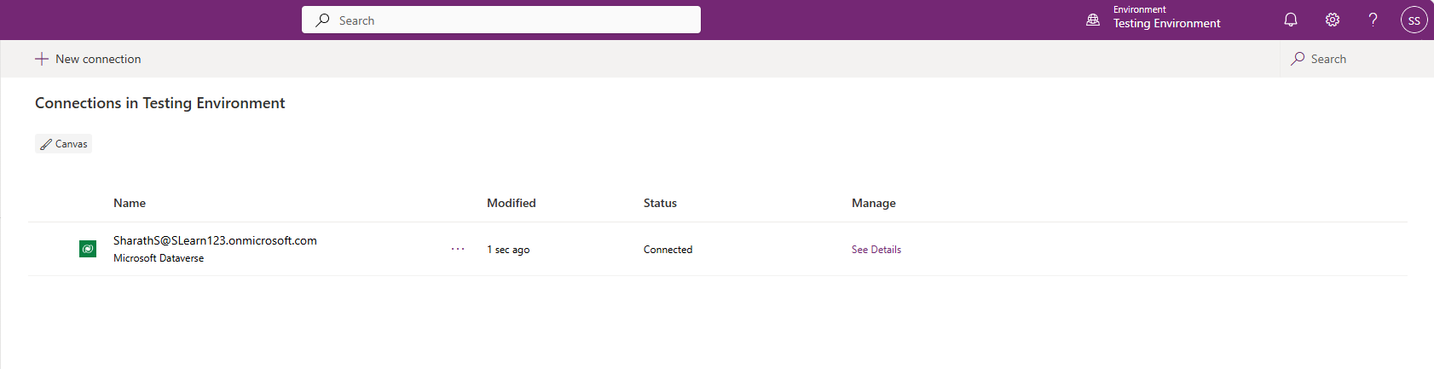
* Import the managed solution.  
  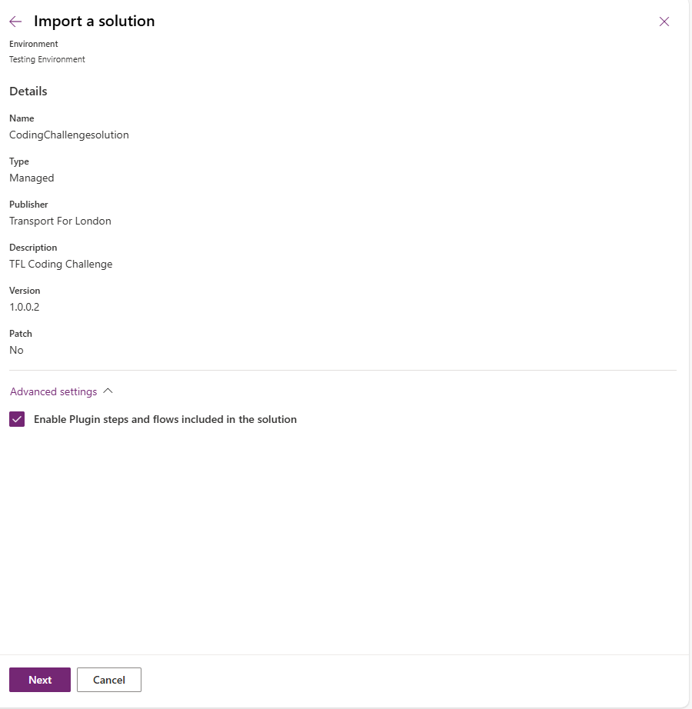  
  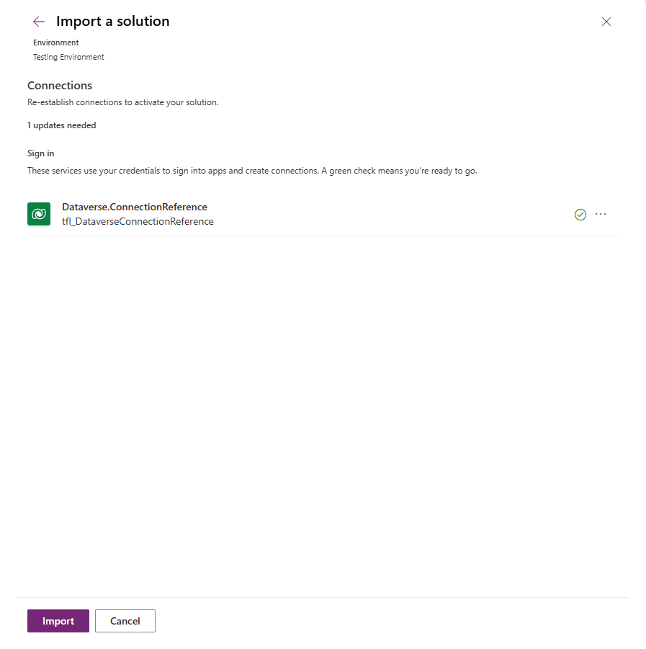
* Run the manual flow “TFL.CreatePostDeploymentConfigurations” to create all the required configuration data.  
  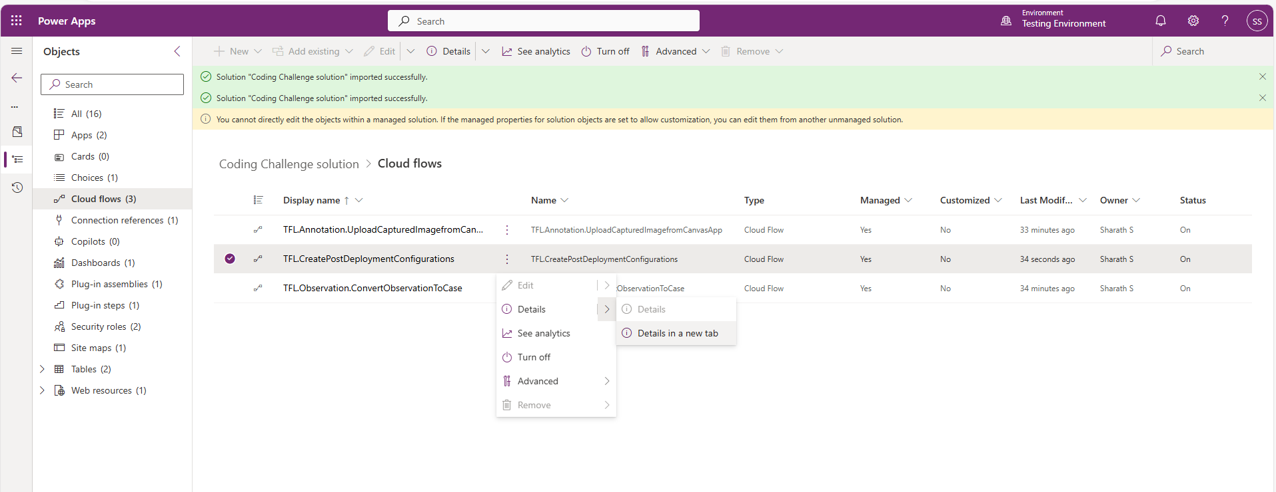  
  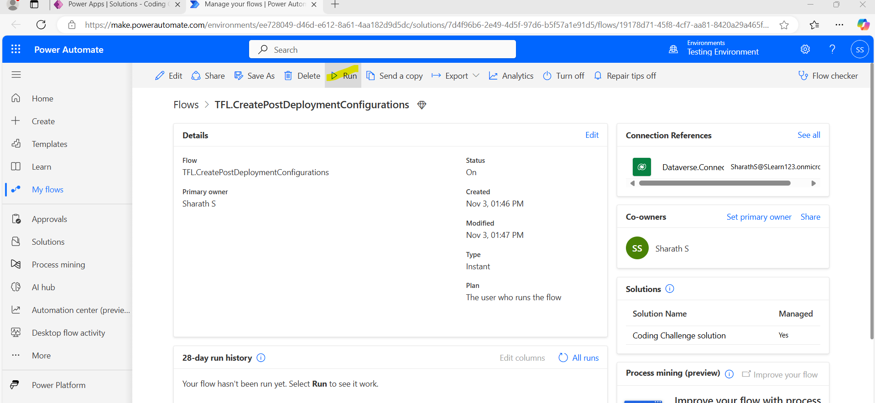  
  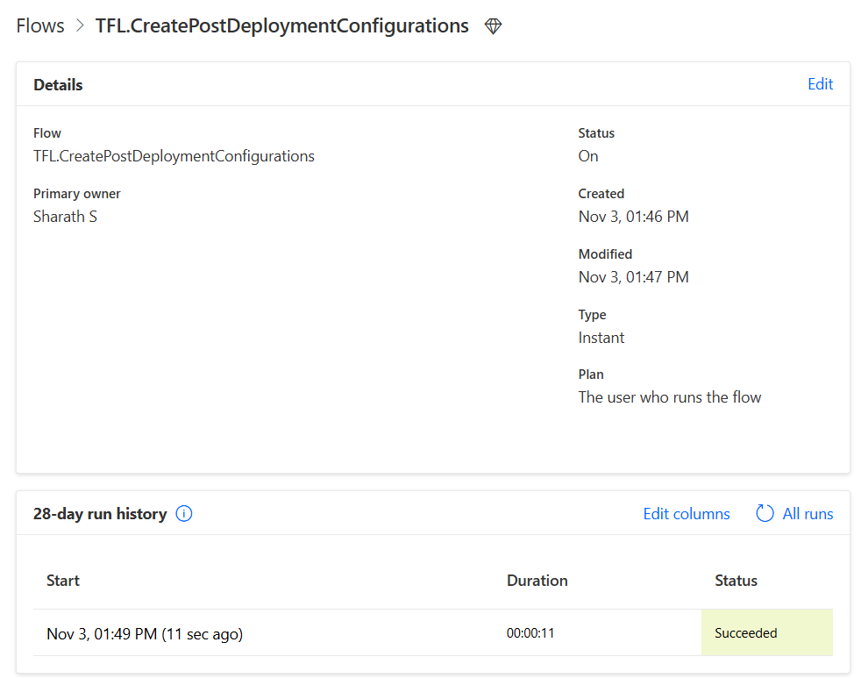  
  The below should create a business unit and default service account  
  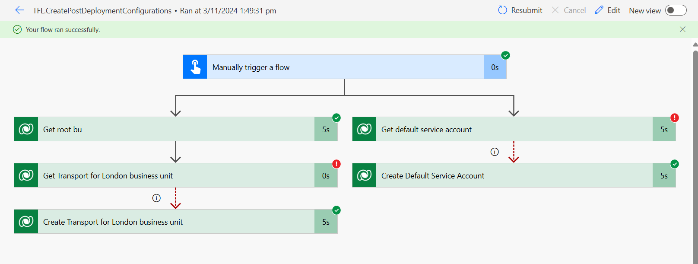
* Add TFL Operations Colleague user to the environment and map to “Transport for London” BU and provide TFL.OperationalColleague.User security role.  
  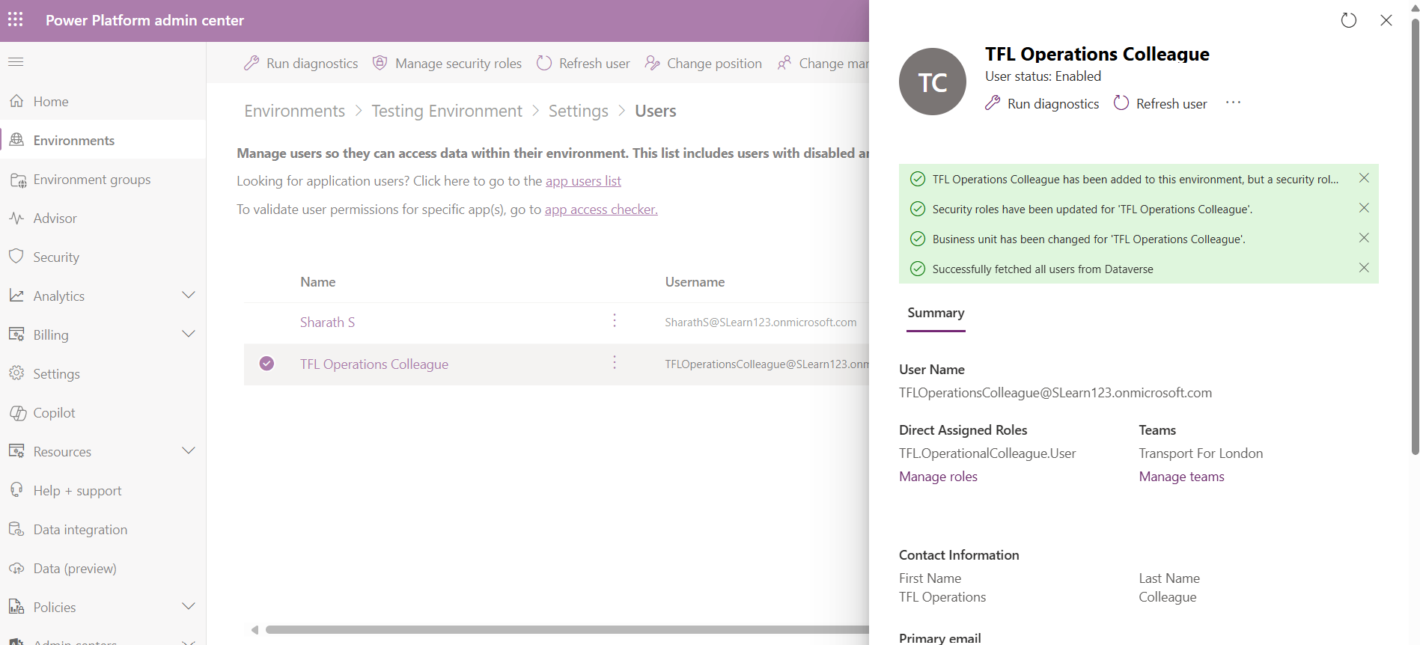
* Add TFL Operations Manager user to the environment and map to “Transport for London” BU and provide TFL.OperationsManager.User security role.  
  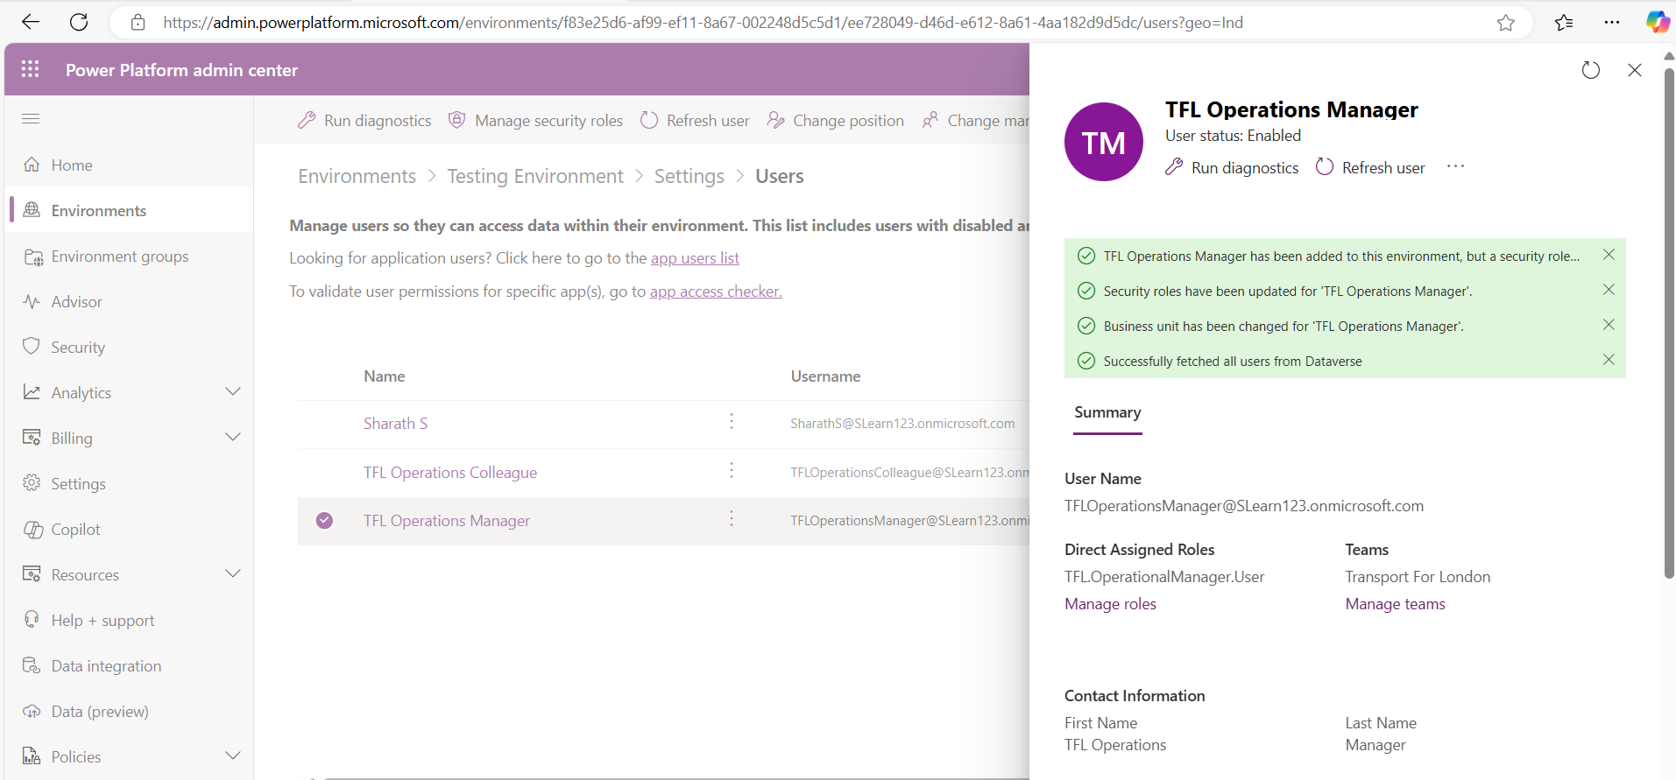
* Share the Observations Canvas App to TFL Operations Colleague user.  
  